National Infrastructure Call for Evidence on the Cambridge – Milton Keynes – Oxford ‘Growth Corridor’

Response from six Local Enterprise Partnerships along the corridor: Buckinghamshire Thames Valley, Greater Cambridge Greater Peterborough, Hertfordshire, Northamptonshire, Oxfordshire, and South East Midlands

Q3. Describe your vision to maximise growth, maintain a high quality environment, and deliver more jobs and homes across the corridor over the next 30 years:
The economies of the six Local Enterprise Partnerships are collectively a high productivity corridor stretching from Oxfordshire to Cambridgeshire and Peterborough. Many of the areas within the corridor have some of the highest levels of productivity per worker outside of London. The economies of the six Local Enterprise Partnerships contribute £165bn Gross Value Added (GVA) per year. But we have not yet achieved the full extent of our economic potential. Our comparators are the highest performing knowledge-based economies around the world, not other sub-national areas of the United Kingdom.
Building on our world-leading and globally competitive innovation- and knowledge-led industries, and underpinned by shared goals and strong collaboration between the private and public sectors and academic partners, we aim to raise our global competitiveness, grow the economy, and build economic resilience for the country. All localities in the corridor can and must benefit from sustained and inclusive growth in productivity and employment.

To accommodate and support forecast population growth 1,600,000 (25% increase) between 2016 and 2051, collectively, we aim to deliver an additional 400,000 jobs (12% increase) and accelerate the delivery of an additional 1,000,000 homes (37% increase) over the same period.

What does that mean for growth and infrastructure investment in your area?
To achieve the levels of growth mentioned above, we need to provide the right conditions for transformative growth. This requires an integrated growth strategy for investment supporting delivery of higher productivity jobs, higher levels of employment, and accelerated delivery of housing to support business-led growth.

What steps are currently being taken to realise that vision, and what more needs to be done?
In order to create the right conditions for growth, the following steps have been taken or are required:
- The Government’s immediate commitment to fund and deliver the enhanced East-West Rail scheme, from Oxford to Cambridge and potentially beyond to Felixstowe.
- A rapid and clear decision on the Oxford to Cambridge Expressway.
- Further investments in unlocking key employment sites: provision of land, forward funding of utilities, necessary transport infrastructure, and working in partnership to navigate the planning process.
- Considerable increase in the rate of housing completions, building on recent rates of increase on existing housing above the national average – a 2.5% increase (or 61,000 additional dwellings) within the corridor from 2012/13 to 2015/16 compared to 1.9% in England).
- Investing in quality public services to support a growing population and build sustainable communities with a high quality of life.
- Investing in local connectivity and capacity to support development and to expand labour and business markets.
- Providing business support, particularly gap-funding to innovative, start-up businesses aligned to our highest productivity sectors.
- Investing in skills (re)training, increasingly aligned to the needs of our emerging and highest growth sectors and to meet identified skills shortages, particularly in construction and engineering.

What value could new cross-corridor intercity road and rail links bring? How do these compare to other transport initiatives e.g. intra-city links, or wider infrastructure, priorities?

Transport Infrastructure
East-West Rail: Although housing completions have increased by 25% in the last five years, we know we can and must deliver housing numbers beyond this to achieve planned growth. Our Local Plans assume that the East West Rail between Oxford and Cambridge via Milton Keynes will be implemented in full. Early commitment to fund and prompt delivery will build confidence required in the market to achieve this planned growth.
East West Expressway: Further significant improvements to east-west connectivity through an expressway along the full length of the corridor will help open-up more strategic sites for housing and accelerate delivery, having the potential for higher levels of housing in the long-term. It would also increase the connectivity of key employment sites and attractiveness to investors and businesses.
Key Interchanges: Investment is also required in key transport hubs to allow the rail systems to operate as a full network by facilitating interchange where lines meet and to ensure sufficient capacity for increased levels of demand and encourage modal shift. The evidence is that well-connected high quality hubs attract investment and support town and city centre transit oriented development and regeneration. The first and ongoing impressions of our key transport gateways matter.
Strategic Local Connectivity: Improved ‘first mile/last mile’ links from key growth locations to transport hubs and network access points would extend potential labour markets and linkages between firms and suppliers, central and support functions of businesses, thereby helping build a knowledge-based ecosystem.

High productivity jobs and their labour markets
Mapping of the workforce densities of the highest typical skill level Standard Occupational Classification (SOC) groups (i.e. 1 - Managers, Directors, and Senior Officials; 2 - Professional Occupations; and 3 - Associate Professional and Technical Occupations) and location densities of higher knowledge/productivity Standard Industrial Classification (SIC) codes shows that higher productivity jobs and the homes of the people who work in these jobs are not co-located. See Figure 1 and Figure 2.
High concentrations of population within the top three SOC codes are concentrated within the London commuter belt especially within Buckinghamshire, Cambridge, Oxford, and historic towns and cities within Hertfordshire (e.g. St Albans and Harpenden). Typically, these areas are well-served by rail connections to central London, which provides a large pool of high-skilled, well-paid jobs for those in the higher skill level occupational classifications. Conversely, the concentration of knowledge jobs within the six Local Enterprise Partnership areas is more dispersed. Knowledge employment is concentrated within Cambridge and Oxford and their rural-urban hinterland, and is also focused on large research and business parks such as Oxford Science Vale, Granta Park, and the Cambridge Science Park. Other smaller clusters are dispersed throughout the corridor, such as Peterborough, Cranfield Technopark, Milton Keynes, and Bicester.
In the corridor, high-knowledge employment is polycentric, often in areas with limited public transport connectivity. This points to a need for high quality, fast, frequent, and reliable public transport to better integrate knowledge employment across the region and to expand labour markets and to improve business-to-business connectivity.

Figure 1: Percentage of higher productivity ‘knowledge jobs’ by Medium Super Output Area
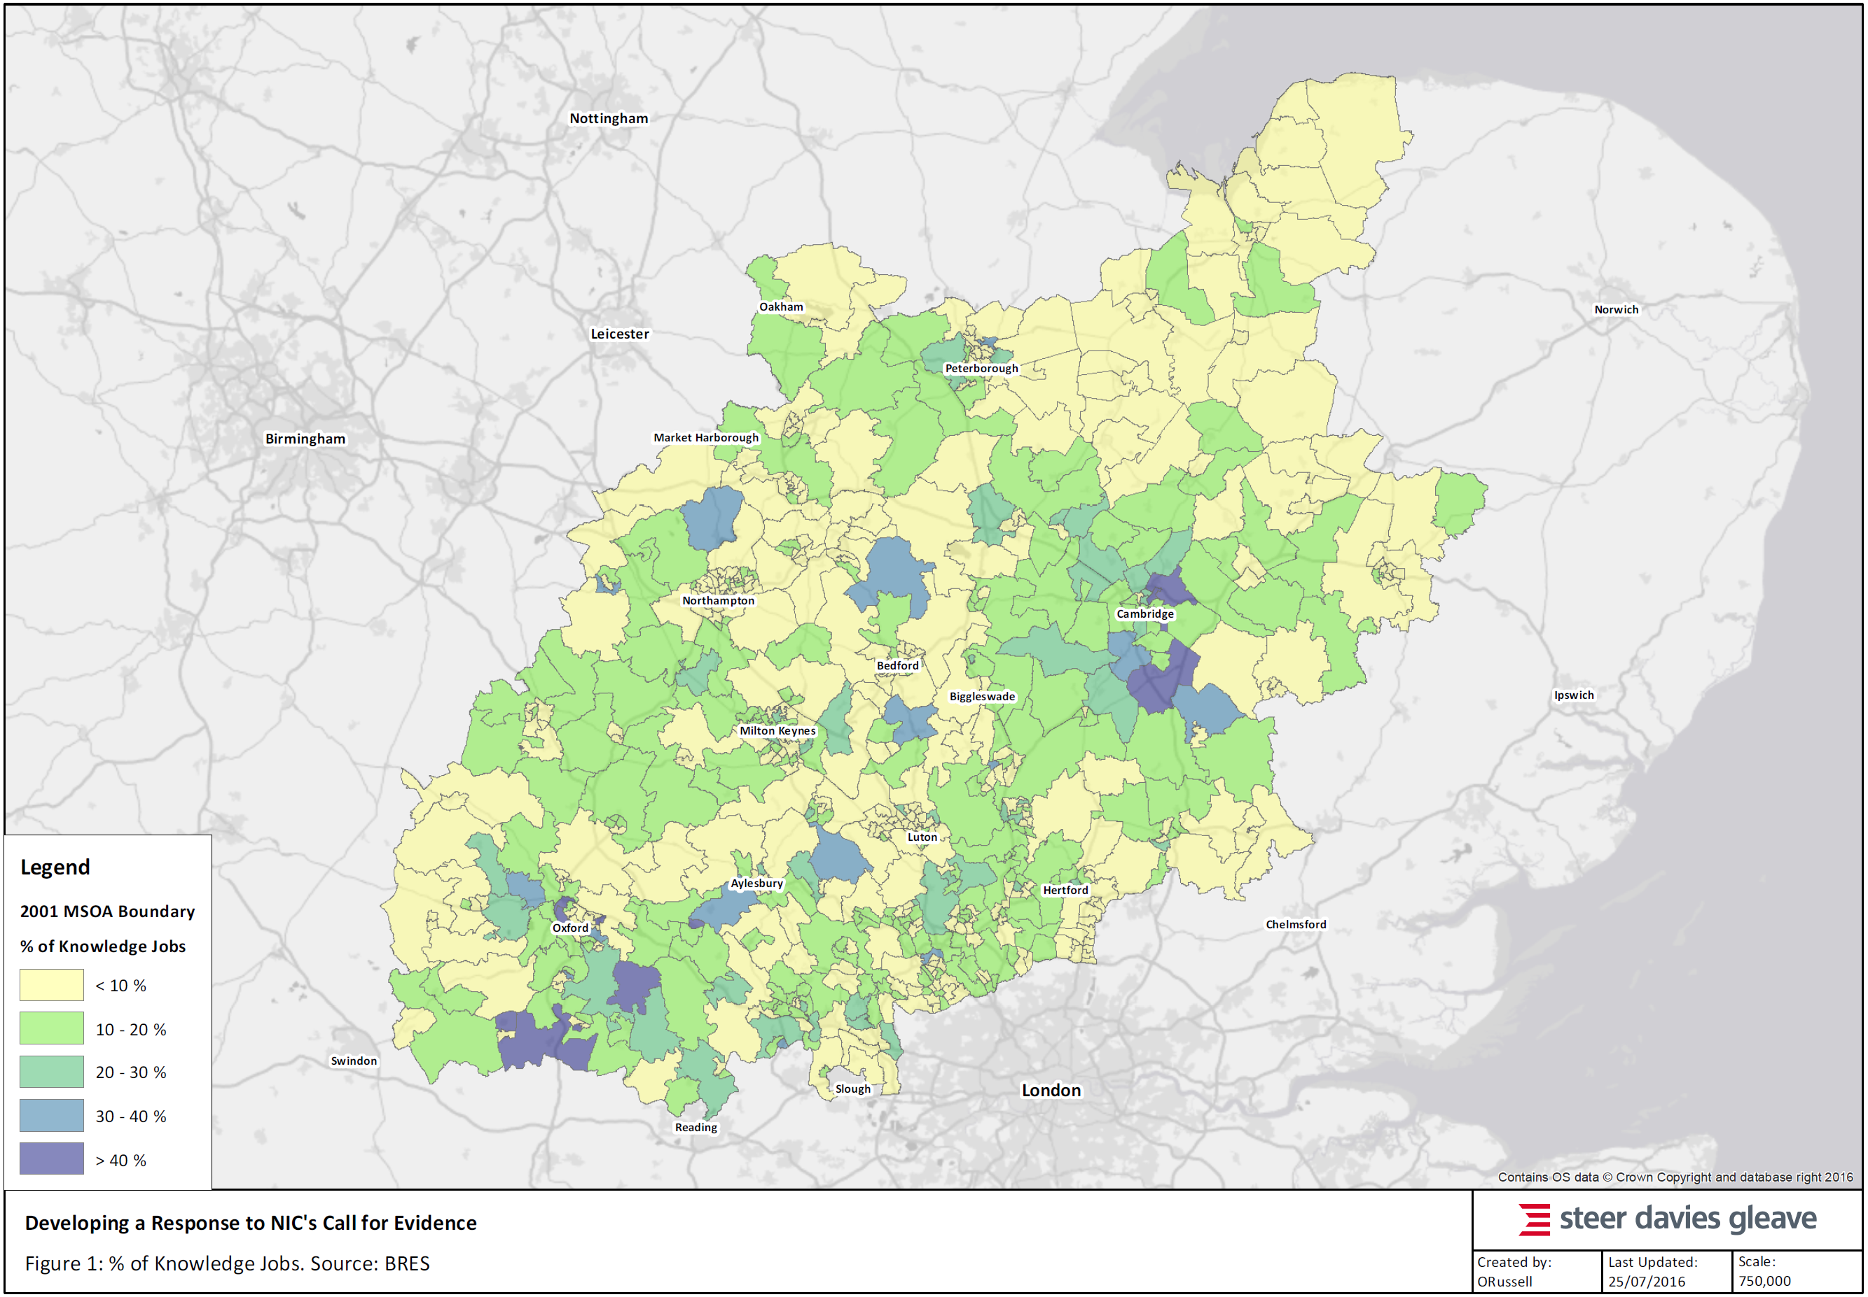
Figure 2: Percentage of workforce in three highest skilled Standard Occupational Classifications by Medium Super Output Area
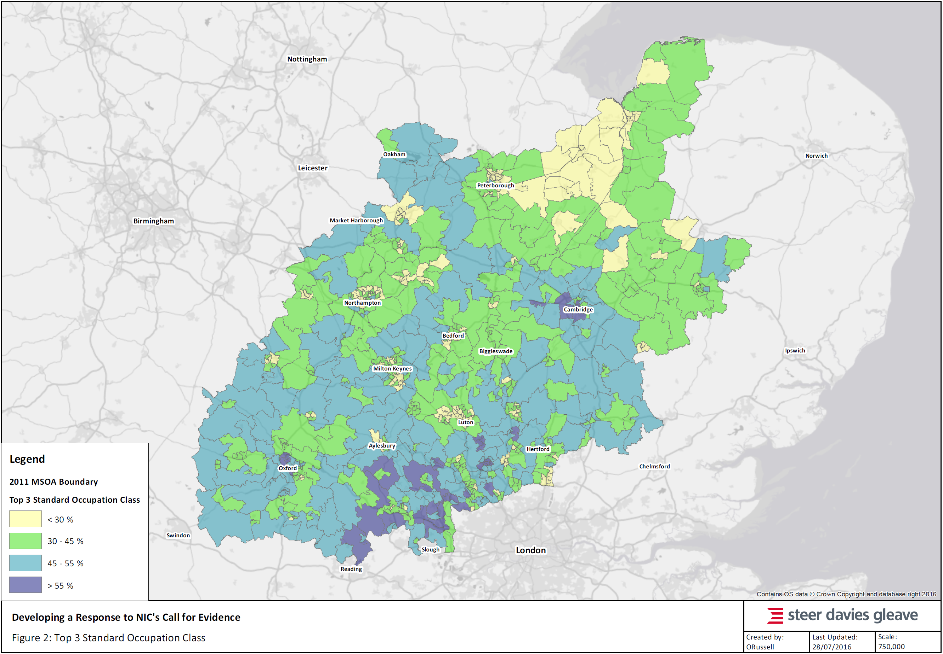

Together East-West Rail, an expressway, and investment in key interchanges and strategic local connectivity will allow partners to ‘crowd in’ investment along the corridor and connect existing urban centres and areas of rapid housing growth into these two critical connectivity spines. Any strategic infrastructure planning, investment and delivery should consider possible changes in technology and how to accommodate, adapt and embrace change to future-proof the investment. It is important that priorities are not seen as an ‘either/or’ between road and public transport; or strategic or local; or transport or other infrastructure – integrated planning, funding, and delivery are required.

Priorities and Wider Infrastructure
Transformational change resulting in a step-change in growth, rather than incremental growth in line with recent trends, will require collective development of an integrated growth strategy by some form of corridor-wide strategic body for growth. To deliver greater and accelerated growth for UK PLC in Exchequer benefits, will need the buy-in of businesses, academia, and local and central government. The National Infrastructure Commission can support accelerated delivery by identifying priorities for investment and helping to give certainty of investment.
Beyond the infrastructure listed above, our priorities for national decision-making and funding are:
- Identification of an integrated sub-national road network made up of Highways England’s network and locally managed roads that needs co-ordinated planning, and funding and delivery of projects.
- More innovative approaches to funding and financing of interchange and strategic local connectivity enhancements, for example flexibilities to allow local authorities to borrow based, in part based on future tax/rates receipts and land values, to invest in facilitating infrastructure.
- For central government to work with local partners to ensure high growth areas have sufficient growth in quality local, public services, specifically larger facilities such as hospitals and further education.
- Investment in digital connectivity.
- Forward-funding/investment in utilities for new employment and housing developments to address commercial viability issues to attract business investment, make commerce easier, and attract a wider range of housing across all tenures that is affordable.
- Acceleration of the planning process, particularly the time taken to take Local Plans, Transport and Works Act Orders, Development Consent Orders and through Public Inquiry with the Planning Inspectorate and Ministerial decision making, to deliver greater certainty.

Q1. Many places across the Cambridge – Milton Keynes – Oxford corridor have very successful local economies and are perceived as highly desirable places to live:

What have been the key drivers of that success?
The key drivers of success in generating a high-value economy with high productivity and employment levels stem from the following five synergistic factors:
- Innovation and knowledge-led businesses in higher productivity sectors: 11.1% of the workforce within the six Local Enterprise Partnership areas along the corridor work in ‘knowledge jobs’. This is above the national average of 9.6% for the United Kingdom. This rises above 14.0% for seven districts – South Cambridgeshire 29.6%, Vale of the White Horse 22.2%, South Oxfordshire 21.8%, Cambridge 18.9%, Stevenage 17.0%, Wycombe 14.8%, and Daventry 14.0% - a polycentric network along the corridor.
The corridor has nationally significant specialisms in: advanced manufacture of computer, electronic and optical products; computer programming, consultancy and related activities; architectural and engineering activities, including technical testing and analysis; and scientific research and development, including life sciences and pharmaceuticals.
In addition to high productivity, knowledge-intensive jobs, there are also typically very high total employment levels along the corridor. It is jobs in other sectors that support the high-value sectors and local communities. It is the combination of high productivity jobs and very high employment that result in the high economic value of the corridor.
- Research institutes and other key economic assets: The corridor had ten universities (see Table 1), along with the Open University which has its headquarters in Milton Keynes. It has two world-leading universities for both teaching and research – University of Cambridge and University of Oxford – consistently ranked in the top five in the world and Cranfield University one the leading post-graduate centre for engineering studies in the UK. The corridor is also in close proximity with good connectivity to other world-leading universities and institutes in London. The corridor’s universities in particular Cambridge, are successful in spinning-out and commercialising many research-led innovations, demonstrated by the high levels of patent per 100,000 of population – four of the corridors cities appear in the top ten of UK cities – Cambridge 101.9, Peterborough 10.5, Oxford 8.9, and Milton Keynes 8.5.
Table 1: Universities in the six Local Enterprise Partnership area
Local Enterprise Partnership | Universities | World Ranking | UK Ranking
Greater Cambridge & Greater Peterborough | University of Cambridge | 4 | 1
 | Anglia Ruskin University | - | 108
Hertfordshire | University of Hertfordshire | 501 – 600 | 76
Oxfordshire | University of Oxford | 2 | 2
 | Oxford Brookes University | 401 – 500 | 55
South East Midlands | University of Bedfordshire | - | 110
 | Cranfield University | N/A | N/A
Northamptonshire | University of Northampton | - | =82
Buckinghamshire Thames Valley | University of Buckingham | - | =38
 | Buckinghamshire New University | - | 109
- Relatively high skill levels and volume: Across the corridor, 32% all residents between 16 and 64 year of age have a Level 4 or above qualification, compared to an average of 30% for England and Wales. For seven districts it is more than 40% – St Albans 50%, Cambridge 50%, Oxford 44%, Chiltern 44%, South Cambridgeshire 43%, South Buckinghamshire 40%, and Vale of the White Horse 40%. This shows the polycentric clustering of highly skilled workforce across the corridor, typically in areas of very high quality of life with good connectivity to London and/or in areas of high productivity, knowledge-led jobs.
- Proximity to major, dynamic world markets, including London, Airports and Ports: All of the largest urban areas within the corridor have four or more direct trains per hour to London and journey times typically of an hour or less, except for Cambridge (three trains) and Oxford (two trains). These offer access to London’s World City functions (e.g. finance, legal, advertising). The same urban areas are all within approximately 60 minutes’ drive-time of an international airport, although the accessibility of Heathrow varies.
Heathrow is currently by far the best connected airport in the country and will remain so for many years to come, regardless of the decision on the location of a new runway in the South East. Furthermore, connectivity from the corridor through to Southampton and Felixstowe also needs to be considered - some of the highest value and growth sectors in the corridor such as advanced manufacturing and the automotive sector require reliable and fast journey times between their plants and ports.
- Quality of life: In addition to proximity to dynamic, major world markets and their transport links, cultural, and retail offers, the corridor boasts many historic market towns and cities. Several of these towns and cities have cultural and retail offerings of national significance, and most historic towns and cities have high quality schools with ‘outstanding’ and ‘good’ OfSTED ratings. Many towns and cities have attractive rural hinterlands and a number of Areas of Outstanding Natural Beauty sit within the corridor (i.e. The Cotswolds, North Wessex Downs, and The Chilterns).
While these strengths build on many historical factors, such as the founding location of industries and higher education institutes, the benefit afforded from these strengths cannot be taken for granted. The current situation underplays the huge potential of locations throughout the corridor.

What is holding back further growth and greater productivity?
The corridor is one of high productivity and very high employment, but productivity and employment are not equal throughout the corridor. There is a need to balance supporting productivity growth with employment to create sustainable and inclusive growth. To achieve significant growth in productivity and employment there are several interconnected key barriers:
- Skills gaps: Our top businesses’ key concern is access to skilled labour. Collectively, we have problems of a skills mismatch, skills retention from our world-class Higher Education Institutes, some low quality schools and further education teaching. As many location reach near full-employment, it compounds the difficulty local businesses find in attracting skilled labour.
- Housing supply shortages and lack of affordable housing: With high levels of labour market participation we are nearing full employment. Without population growth, our economic growth will be constrained. To serve the huge potential increases in employment and natural population growth, we will need to considerably increase the rate of housing delivery, with appropriate housing mix for both sale and rent, including the private rented sector. Despite several of the corridor’s largest urban areas being constrained by their administrative boundaries, there is strong local and political will and ambition for housing growth. The relatively low increases in housing completions compared to the growing demand means that affordability is increasingly a problem – five out of our six Local Enterprise Partnership areas and three-quarters of all our districts and boroughs have higher average house price to average earnings ratios than the national average of 7.5 (see Figure 3). We need to promote delivery of homes of the right quality and mix to meet the future needs of a growing and ageing population.
Figure 3: Ratio of Median House Price to Median Household Earnings by Local Enterprise Partnership 2004 – 2015)
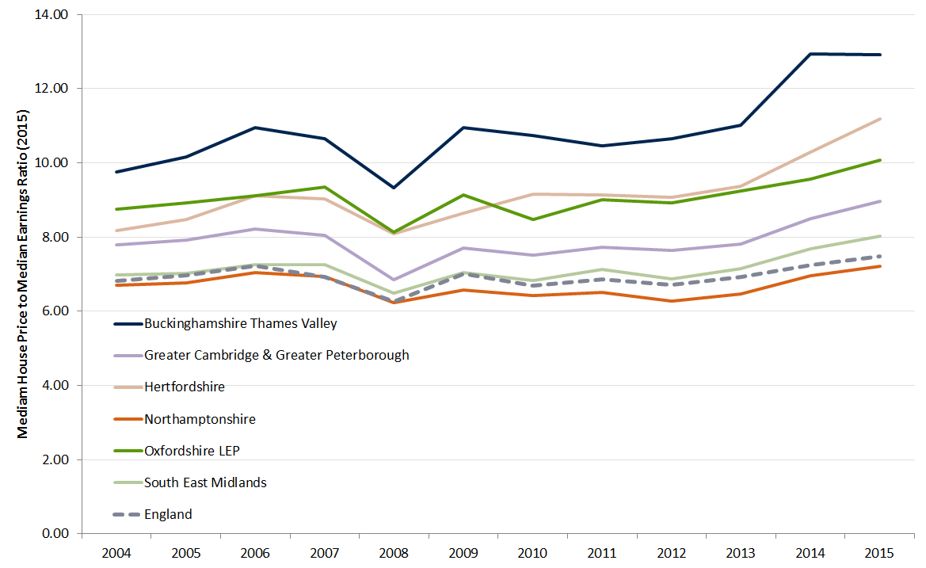
- Difficulty in connecting to wider labour and business markets: Travel times to London may be quick but are capacity constrained and subject to delays and uncertainty over journey times. Inter-urban travel times between the largest urban areas in the corridor, particularly by public transport, are slow and can take considerably longer than an hour. The best rail route is often via London. Together these factors constrain growth. East West Rail and main line connections for interchange have the potential to form a public transport grid network significantly improving connectivity to other major centres of growth and port.

Corridor Connectivity – Journey Speeds
A useful comparator for the road and rail connectivity in the Cambridge – Milton Keynes – Oxford Growth Corridor is the Thames Valley, which has the M4 and Great Western Mainline as its transport spine.
Average speeds on journeys between the key economic centres along the Cambridge – Milton Keynes – Oxford corridor are between 35 and 51 miles per hour by road. In comparison, journeys along the Thames Valley / M4 corridor (with the exception of journeys involving London) typically have speeds of between 50 and 61 miles per hour.
Rail journeys between Cambridge, Milton Keynes and Oxford are slow requiring a change either in London or a sub national hub. In comparison, journeys between London, Reading, Bristol and Swindon provide faster speed across similar distance with speeds of between 69 and 84 miles per hour.
The connectivity in the Thames Valley corridor with the M4 and Great Western Mainline attracts very high productivity, knowledge intensive industries and also facilitates significant agglomeration benefits. This has contributed to Thames Valley Berkshire Local Enterprise Partnership having a GVA per capita of 174% of the English average, the highest of any single Local Enterprise Partnerships outside of London.

- Commercial viability issues, particularly for employment and strategic sites for housing outside the area under the direct influence of London: The key issues are the need for ‘forward funding’ of road capacity, access enhancements, and utilities, especially electricity. There is a need to address these issues in partnership with developers and the Homes and Communities Agency. With regard to utilities, there is a need to work with utility companies and regulators to forward plan, but also address the issue that utility companies are not obliged to serve new developments in advance of them coming on stream.
- Lack of joined up planning and investment for wider public services: Areas that support high growth need to be supported by central government with investment in key public services (e.g. schools, further education, care services, hospitals, local bus / mobility services, waste) to provide quality services that keep up with the pace of growth.

In particular, what planned or new infrastructure improvements would best support sustainable growth and promote innovation over the long-term?
As already set out, all Local Enterprise Partnerships along the corridor are planning on the basis that East-West Rail is a committed scheme. Enhanced road connectivity within corridor is important through an expressway. In addition, investments in strategic local connectivity, fast and reliable digital connectivity, and public services are essential.

Does the corridor require better connectivity to other major centres of growth?
Investment in East-West connectivity as well as in key interchanges, and ‘first mile/last mile’ connectivity will allow our transport systems to work as proper networks, providing improved connectivity to other major centres of growth for all localities throughout the corridor.
Outside of the corridor, rail connectivity improvements to London and its international airports are a priority. Whilst commuter services are generally fast and frequent, a further knowledge-based growth will increase rail demand further. There are significant bottlenecks that constrain growth in ridership and freight movements, reliability and resilience. Without addressing these, the demand for travel and goods movement generated by higher growth might not be accommodated.
It is now imperative that there is an unequivocal decision from Government on how runway capacity in the South East of England will be increased.

Q2. Does the Cambridge – Milton Keynes – Oxford area, including Northampton, form a recognisable economic corridor? If so:
Looking at current travel patterns, the corridor does not form a single travel to work area. Rather, it has a number of overlapping travel to work areas centred on Cambridge, Oxford, and Milton Keynes/Bedford/Northampton/Luton/Dunstable. But to us, this is the wrong question. The question should be, does the corridor have the potential to function more as a single Functional Economic Area and what advantages would this bring to the national economy?

What factors unite the area?
The unity of the corridor is defined by its current characteristics, its ambition and its potential:
- Its high performing sectors and high levels of Foreign Direct Investment.
- Its potential for innovation- and knowledge-led growth to accelerate its role as a globally competitive area which has the highest productivity area in the country outside of London.
- To accommodate further employment growth to support those high productivity sectors.
- The potential to create an economic mass which can support a self-sustaining knowledge-based ecosystem.
- The ability for different parts of the corridor to provide accelerated housing growth to support its productivity ‘growth poles’. For example, Milton Keynes and Bicester, Northamptonshire and South Cambridgeshire to provide housing for employees in Oxford and Cambridge.
- Land and a willingness to provide the amounts and types of housing that a growing knowledge-based economy will require.

Would greater emphasis on corridor-wide planning and decision making benefit local communities and local economies? Would that same emphasis on coordinated planning and decision making provide wider benefits for the UK economy?
Throughout this response we have identified that additional infrastructure is required along and throughout the corridor to connect its ‘growth poles’ together and connect them to their labour and business markets and international gateways, and to provide capacity for such movement that not only accommodates growth but also acts as an incentive for investment.
This means coordination between local government and between local and central government, including its national delivery bodies (Network Rail, Highways England, and the Homes and Communities Agency) and effective working with utility companies.
Co-ordinated corridor-wide planning and decision making is needed if our growth potential is to be delivered. Options for a special purpose vehicle for integrated planning should be considered. However, this does not mean that governance reform is a prerequisite to achieve this and we consider that provided partners are sufficiently resourced these goals can be achieved within the context of existing governance structures.
It also means that investment is required in wider infrastructure to ensure that more can benefit from the investment in strategic infrastructure, to support growing local communities, and to provide equitable and inclusive growth – optimising the benefit of the investment for sustainable growth.

Should adjacent towns and cities be incorporated into the corridor in terms of growth and infrastructure planning?
Adjacent towns and cities should be considered. In particular, Swindon, which demonstrates many similar characteristics with the corridors’ other fast growth, high productivity urban areas. Swindon has very strong links to Oxfordshire through its advance manufacturing automotive industry. Without enhanced connectivity, growth in this sector is held back.

Q4. Are there lessons to be learnt from previous initiatives to maximise the potential of the corridor?
There are multiple models that have worked in the past with lessons learnt that can be shared and continue to be evolved locally. For example, The Cambridge Phenomenon – university-led, innovation-led growth over several decades; supported by the public sector through forward funding of infrastructure, and collectively providing land, low cost space, and strong business support; backed by a singular shared vision which has given confidence to industry and local partners. The integration of lessons learnt is already in practice and is part of our proposition. For example, Didcot and Science Vale which have the potential to bring similar benefits to Oxfordshire.
However, we need something additional to achieve the transformational potential rather than deliver more of the same.

The current push for the formation of Combined Authorities is understandable for urban areas centred on big cities, but it is not the only model for strong governance, accountability and accelerated delivery and growth, as evidenced above. Whilst work is underway for the formation of a Sub-National Transport Body, England’s Economic Heartland, it would be wrong for the corridor to be penalised and constrained in delivering genuinely high levels of growth for the country by developing its own successful models for planning, delivery and growth. We do and will continue to work collaboratively locally and with national partners to accelerate delivery and growth.

Q5. Are you aware of any examples of UK or international good practice, for example in respect of new technology, local frameworks or the built environment that are relevant to this review?
Through comparison of population, knowledge-sectors, and Gross Domestic Product (GDP) per capita, globally competitive regions such as the Rhein-Pflaz around Mainz and Koblenz compare favourably – Germany’s highest export rate of 50%, specialising in advanced manufacturing in automotive and pharmaceutical sectors,. Further work could identify key drivers, barriers and opportunities for such comparable, globally competitive areas.
To grow as a truly global competitor it is important to look to successful international comparators – those reviewed are:
- The Eindhoven-Leuven-Aachen Triangle (ELAT), Western Europe;
- The Randstad, Netherlands;
- Boston (MA), United States of America; and
- Singapore.
Key lessons learnt include:
- Good connectivity and high productivity go hand in hand: This is both local physical and digital connectivity supporting wide labour markets and business to business links and longer distance (typically international) connectivity to access supplier, markets and collaborators. Applying this lesson to the Oxford to Cambridge corridor, this means enhanced connectivity east-west within the corridor, to elsewhere in the UK and notably to London and to port and airport international gateways. To support the planning and delivery of the last of these and as already a clear and unequivocal decision on the location of additional runway capacity in the South East is needed urgently. High productivity is associated with strong links between the public sector, private sector and academia. A clear public sector led infrastructure plan with a credible delivery programme helps give the private sector the confidence needed to support their locational and investment decisions. Private and education sector involvement in the development of such plans increases their credibility further.
- Looking across the globe, there is no single governance model associated with high productivity growth: Some examples are top-down and dirigiste, other are collaborative involving multiple tiers of local and regional government and a principal of subsidiarity, and in some cases, multiple national governments. However, what is common is a clear strategy and plan, often supported by bespoke delivery bodies.
- Clear route to funding and financing: Associated with these strategies and plans is a clear route to funding and financing infrastructure enhancements and so delivery.

Endnotes Source: Office for National Statistics GVA for Local Enterprise Partnerships (2014) for GVA by LEP and Business Register and Employment Survey (2014) for employment numbers. Six Local Enterprise Partnership average GVA per employee of £57,000 compare to England and Wales average of £53,000.
Source: Office for National Statistics GVA for Local Enterprise Partnerships (2014).
Source: National Trip End Model v7 (July 2016).
Source: P2 returns from local authorities for National House-Building Council (NHBC). Table 255: permanent dwellings started and completed, by tenure and Local Enterprise Partnership.
Fourteen ‘knowledge sectors’ were defined from the Business Register and Employment Survey (BRES) classification, at the 2-digit ‘division’ level, out of a total of 88 2-digit divisions. Such a categorization was adopted through analysis of the Local Economic Plans of the Local Economic Partnership of each city region, and identification of the core knowledge sectors which they target.
Source: Business Register and Employment Survey 2014.
Source: Times / Sunday Times 2016 Ranking for UK Universities: https://www.ukuni.net/articles/UK-University-Ranking-2016-Times (accessed 27 July 2016) and Times Higher Education 2016 Rankings for World Universities: https://www.timeshighereducation.com/world-university-rankings (accessed 27 July 2016).
Source: Intellectual Property Office 2015, Freedom of Information release: Patents granted registered by postcode, 2014 data, NOMIS 2015. From Cities Outlook 2016 (Centre for Cities, 2016)
Source: 2011 Census. Local Area Analysis of Qualification across England and Wales - highest level of qualification by country of birth by age.
Source: 2100 Census. The following town and cities have a population of 75,000 or more in descending population: Northampton 215,000, Luton 211,000, Milton Keynes 172,000, Peterborough 162,000, Oxford 160,000, Cambridge 146,000, Watford 132,000, High Wycombe 120,000, Hemel Hempstead 95,000, Stevenage 90,000, and St Albans 82,000.
Source: www.thetrainline.com (accessed 27 July 2016) for an hour between 7:30am to 9:00am departing to a London Terminus on 28 July 2016.
Source: Google Maps without traffic drive-times (accessed 27 July 2016). Longest drive-time: Peterborough to London Stansted Airport 61 minutes.
Source: Price to earnings ratio data, Ratio of median house price to median earnings by Local Authority, Department for Communities and Local Government 2013.
Source: https://www.google.co.uk/maps (accessed 27 June 2016) for 8:00am drive-times on 28 July 2016 and road distances. www.thetrainline.com (accessed 27 July 2016) for average train times between 7:30am to 9:00am on 28 July 2016. https://www.google.com/earth/ (accessed 27 July 2016) for ‘straight line’ distances used for rail speeds.
NEED LEP DATA.
Source: Average annual population by NUTS 3 regions and gross domestic product (GDP) at current market prices by NUTS 3 regions from Eurostat.
Source: Wikipedia for Rheinland-Palatinate https://en.wikipedia.org/wiki/Rhineland-Palatinate (access 27 July 2016).

